

SWWC Service Cooperative

Junior High

KNOWLEDGE BOWL®

Coaches’ Handbook



2025-2026

TABLE OF CONTENTS

Regional Service Cooperatives 3
General Information 4
Questions 5
Competition Structure 6
Rules for Team Members 7-8
Power Ranking Procedure 9
Score Sheet 10
Schedule of Events 11
Snow Dates and Conflicts 12
Team Roster and Code of Conduct 13
Code of Ethical Conduct 14
Coaches Statement 15
Equipment and Software Information 16
Equipment and Software Order Form 17
Rules for Judge 18-19
Rules for Reader 20-21
Rules for Equipment Operator 22
Minnesota

Service Cooperatives

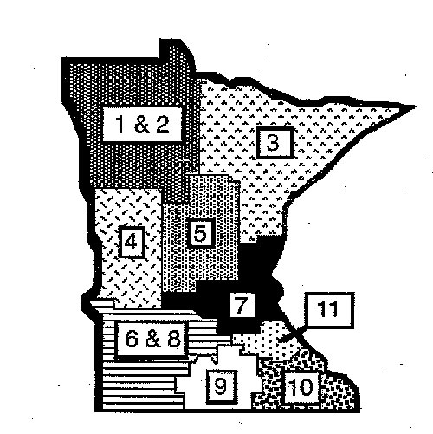

Region 6 & 8

SWWC Service Cooperative
100 London Road, Marshall, MN 56258
Gail Polejewski, Regional Knowledge Bowl Coordinator
507-537-2273
Fax: 507-537-7327

Email: gail.polejewski@swwc.org
www.swwc.org/kb
The following pages include suggested guidelines for local, sub-regional, and regional competitions.

For any further information, assistance, or questions, please contact your regional service cooperative KNOWLEDGE BOWL® coordinator listed on the preceding page.

GENERAL INFORMATION

Minnesota Service Cooperatives’ Junior High KNOWLEDGE BOWL® competitions are interdisciplinary academic contests designed for students in grades 7-9. Teams may be made up of younger students. Ex: 5th and 6th graders can participate on a Jr. High team. During the contest, teams of students compete in written and oral rounds by answering questions related to all areas of learning, typical of junior high educational programs. Questions test students’ recall, problem-solving, and critical-thinking skills. This competition provides a format for student growth centered on academics.

TEAM COMPOSITION

A junior high KNOWLEDGE BOWL® team consists of six (6) members only, including the alternate. Six members compete during the written round; only five members compete during the oral rounds. A member of each team is appointed as a spokesperson, and this person should, if possible, give the answer for all questions. Other team members can feed the answers to the spokesperson. An alternate spokesperson may ONLY be designated prior to the expiration of time.

NOTE: Any team qualifying for and attending the regional competition must be comprised of the same students who were registered on the winning team in the sub-regional competition. If you know a student will be absent for the sub-regional event, but want that student to be on the team if they advance to the regional event, that student must be one of the six registered for the sub-regional team.

Once an oral round has started, there will be no scoring changes on any of the previous rounds, including the written round.

QUESTIONS

The questions have been developed in several curriculum areas proportionate to the relative emphasis each area receives in a junior high curriculum. The questions have been randomized so that within each round, there will not be a string of items from a particular curriculum area. Questions test students’ recall, problem-solving, and critical-thinking skills.

There are written and oral questions during the course of the competition. Depending on the level of competition, the format includes one written round and three, four, or five oral rounds. Five alternate oral questions are included at the end of each round for use at the discretion of the reader and/or judge.

The number of oral rounds that will be used at the sub-regional and super-regional events will be decided at the fall coaches’ meeting; it is usually four rounds.

Minnesota Service Cooperatives’ KNOWLEDGE BOWL® secures pristine question sets for the sub-regional and regional events. The question sets are distributed throughout the state.

WRITTEN ROUND

Each junior high KNOWLEDGE BOWL® competition consists of one round of sixty (60) multiple-choice written questions with a time limit of fifty (50) minutes. One point is awarded for each correctly answered question; points are not deducted for incorrect answers. This written round score is combined with oral round scores to determine team placement.

During the written round of competition, the team of six members works together to answer the questions with answers placed on a standard form. This round allows students to work cooperatively and assesses what they do well when speed is less critical.

ORAL ROUNDS

In an oral round, forty-five (45) questions are asked. The reader asks the question orally and the teams press down on a pressure-sensitive tape attached to the equipment when they think they can answer the question. After buzzing in, team members discuss their answer with one another before providing the judge with an answer. Scratch paper is available at all times for the teams’ use. The appointed spokesperson may ONLY be designated prior to the expiration of time. Points are awarded for correctly answered questions.
COMPETITION STRUCTURE

Teams compete in multiples of three (3), partly due to the judging devices, which permit three teams to buzz in, but mostly due to the fact that a group of fifteen students (3 teams of 5 students) almost always turns up a correct answer.

Each room is set up with tables for three teams facing the judging table. The judging table seats the reader, judge, and equipment operator, along with the equipment.

The diagrams below give a visual depiction of the table setup. You can see the center judging table and three tables at which teams sit. Note the pressure-sensitive tapes, which run down the center of the team tables. This seating arrangement allows all five team members to respond while seated facing the reader, judge, and equipment operator.

Scratch paper and table tents will be provided. Only the pressure-sensitive tape, scratch paper, and pencils are allowed on the table during the oral rounds. No books, purses, etc. are allowed on the table. Teams are asked to take paper/pencil with them at the end of the round, leaving a clean table for the next round.

One note of caution: Team alternates or any other observers in the room are not allowed to talk out loud or respond in any other way to fellow team members. No one except competing team members may dispute a question or answer with the reader and judge.

Teams consist of up to six members. Up to five members compete during the oral rounds. Team members may be substituted between rounds. Alternates must stay in for the entire round.

Competition starts with the written round. Starting with the written round allows the readers and judges time to go over the oral questions.

Team coaches typically serve as readers and judges during local, sub-regional, and super-regional events.

**As representatives of their schools, KNOWLEDGE BOWL® competition participants are to remove caps/hats for the competitions and be careful not to wear clothes with offensive symbols/words.
Competition Seating Arrangement
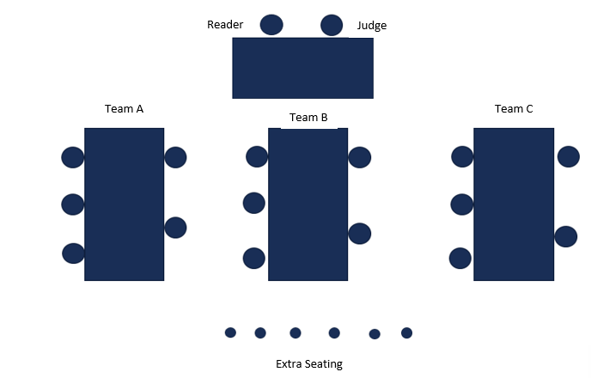
KNOWLEDGE BOWL® Competition Rules
Team Members

- Student participants are recognized as representatives of their school districts and their communities. We celebrate your sportsmanship and appreciate your cooperation.
- Teams consist of up to six members. Up to six members complete during the written round and up to five members compete during oral rounds. Team members may be substituted between rounds. The Alternate must stay in for the entire round.
- Identify a team spokesperson. The spokesperson on a team is expected to give the answer. The alternate spokesperson must be designated prior to the expiration of time by saying “I defer to …” (can point to another member or say their name) or use similar language. When answering a question, speak as clearly and loudly as possible.
- The reader will wait five minutes for a tardy team and/or team member at the start of any oral round. If the team and/or team member is not seated at the competition table during that five-minute period, the team and/or team members will not be allowed into the competition room until the score check following questions 15 or 30. (If the tardiness is caused by a delay in other competition rooms, the reader/judge will wait to begin the competition without penalty to the team.)
- The reader will call out the question number and read the question to the three teams. The question officially starts as soon as the reader begins to pronounce the question number. If the team chooses to answer, a team member touches the pressure-sensitive strip to register in on the equipment. When a team registers in on the equipment, the reader stops reading the question at that point. The equipment operator will call out only the first team to register.
- The reader indicates when the team’s discussion time is up by saying “Answer___”. Teams must answer within 3 seconds. If the team does not respond immediately, the reader says, “No answer”, and the equipment operator calls out the next team that registered in. Once the question is read in its entirety, and so noted by the reader to the teams, the teams have 3 seconds to buzz in. If the wrong answer is given by a team, the other teams who have not buzzed in have 3 seconds to buzz in or the reader will move on to the next question.
- No team may answer without having registered in on the equipment.
- Questions will be read in their entirety if no other team has registered in. For example, if the first team registered in fails to answer the question which has NOT been read in its entirety and no other teams have registered in, the reader will automatically read the question again, in its entirety, starting at the beginning. Any teams eliminated from a question due to an incorrect answer will be excluded from alternate questions used due to procedural problems, on that same question.

********QUESTIONS MAY BE READ IN THEIR ENTIRETY ONE TIME ONLY.********

- The spokesperson, or their designee, is the only person who may request clarification on disputed questions, and this can only be done at the time it occurs and before the next question is read. Should a disagreement about an answer occur, the judge has the final say. ALL ROOM DECISIONS ARE FINAL.
- The judge has control of consequences for unsportsmanlike behavior by team or audience members. Suggested guidelines: first time: official verbal warning; second time: team member is asked to leave the competition room and is disqualified from participation in the competition. In all cases, the competition coordinator is notified as well as team coaches of affected students.
- The articles that begin titles (“a”, “an”, “the”) can be excluded from consideration as part of the answer.
- A team may respond with one piece of relevant information in addition to the answer, which is related to that specific question. If more than one piece of relevant and related information is given, or if the reader or judge doesn’t know if that second piece of information is correct, the answer will be rejected with a statement of “incorrect answer.” Any information contained in the question is not considered extra information. The articles that begin titles (“a”, “an”, “the”) can be excluded from consideration as part of the answer. Information that is printed in the question (read or unread) is not necessary in the answer but may be included without penalty.
- If cell phones or other electronic devices are seen or heard during competition rounds, the student violating the policy will be disqualified for the remainder of the round. Additionally, the team will forfeit any points they have earned in that round up to that point. The team may continue, and the student may rejoin the team for successive rounds
POWER RANKING PROCEDURE

Teams are ranked after the written round and after each oral round.

Following the written round, teams are ranked according to written round scores. Teams with the highest three scores go to the designated competition room for oral round one. Teams with rankings four, five, and six go to the next designated room, etc.

After oral round one, the teams are ranked by adding the written round score and oral round one score. Cumulative scores after each round place teams in the respective competition rooms.

Strength of Scoring (SOS) points will be given at the end of the meet as follows: each time in top room = 1.5 pts./round, each time in 2nd room = 1 pt./round, and each time in 3rd room = .5 pt./round. Only the top three rooms get SOS points.

Alternate methods of ranking may be used for local, and invitational meets at the discretion of the host.

Tie Breaker Rounds

- If a tie exists following the written round, room assignment and placement will be determined by the alphabetical name of the school district.

- If a tie exists following any oral round, the team will be ranked based on points scored in the oral round just completed (more points result in a higher rank). When those scores are also tied, teams will be ranked in the same order that they were ranked before the oral round just completed.

- After the final oral round, after SOS points have been added, cumulative score ties for crucial placement in ranking between third and fourth or sixth and seventh will be determined by a tiebreaker round consisting of fifteen questions. Ties after one tiebreaker round of fifteen questions will be determined by sudden death in overtime.

- If there is a four-way tie for first place after the final oral round, placement will be decided as follows: The four teams will compete in pairs according to a random draw by the spokesperson. The round will be run as in number three above. The winner from each will be placed in the championship round. The losers in each round will compete for third place with another fifteen questions.

Schedule of Events
LOCAL COMPETITIONS
Region 6 – November through February
Region 8 – November through December

Each Service Cooperative region conducts a meeting for its team coaches in the fall. The purpose of this meeting is to prepare and plan for the upcoming season. Decisions affecting the schedule and procedures for the local competitions are regional decisions; however, the rules and guidelines adopted by Minnesota Service Cooperatives’ KNOWLEDGE BOWL are to be implemented and followed on a regional basis for all competitions.

Suggestions:
If you are hosting a local competition, determine how many teams will compete (in multiples of three). You will need one room for each group of three teams. Host schools arrange for competition rooms, questions, readers, judges, and concessions (optional).

SUB-REGIONAL COMPETITION
December

Most Service Cooperative regions allow all registered teams to participate in a sub-regional competition held at Southwest Minnesota State University.

Registration Deadline – December 2, 2025
No registrations will be accepted after the registration deadline.

Region 6
January 12, 2026- SMSU (snow date – January 13)

Region 8
December 16, 2025 - SMSU (snow date – December 18)

SUPER REGIONAL COMPETITION
January

The number of teams competing in the regional event is a regional decision. In Regions 6 and 8, approximately half of the teams participating in the sub-region meets advance to the Super Regional meet. The final number of teams is determined by a final calculation, allowing for 3 teams in each competition room.

Super Regional
January 15, 2026 - SMSU (snow date - January 16)
Policies on Snow Dates and Conflicts

Snow Dates
If schools cannot attend on the sub-regional snow date because of a school closing or another major event, the coach may determine how many teams would have realistically advanced to the Super-regional event (examples: 2 of 3, 1 of 4.) Those teams will be allowed to participate in the regional event unless objected to by the other participating coaches.

Conflicts with Regional Dates
Teams advancing to the Super Regional event but unsure of their ability to participate because of conflicts (or possible conflicts) with another activity, must decide at the sub-regional event, so if they choose not to advance, the next eligible team can be notified immediately. As a courtesy, the team and coach should make the decision prior to competing in the regional event.

Originally discussed at Spring Meeting on April 30, 2007
Policies voted on at Fall Meeting on September 20, 2007
Updated September, 2016
Note: This form is available on our website: www.swwc.org/kb. Please complete the form and turn in when registering at the sub-regional event.

JUNIOR HIGH KNOWLEDGE BOWL® TEAM ROSTER

Prepare one sheet per team, have students sign the bottom part, and bring form to the sub-regional event.

Date of Event: Site:
Name of District:
Advisor(s):
TEAM # or Name: (need only if more than one team from your district)
Team Members: (please print) Grade

1 4

2 5

3
Alternate

Minnesota Service Cooperative KNOWLEDGE BOWL®
Code of Conduct

- As a student participating in the Minnesota Service Cooperative KNOWLEDGE BOWL® competition, I understand
and accept the following responsibilities when participating in all events:

- I will respect the rights and beliefs of others and will treat others with courtesy and consideration.

- I will be fully responsible for my actions and the consequences of those actions.
- I will respect the property of others.
- I will respect and obey the rules of my school, the host site, and the laws of my community, state and country.
- I will abide by the rules of the event.
- I will show respect for and abide by the decisions of the competition officials and host site personnel.

- By signing this, we acknowledge that we have read and agree to the above statements.

- We understand that failure to adhere to this Code of Conduct may result in the disqualification of the student
and/or team from further participation in any event.

Student’s Signature

Student’s Signature

Student’s Signature

Student’s Signature

Student’s Signature

Student’s Signature

KNOWLEDGE BOWL® CODE OF ETHICAL CONDUCT

KNOWLEDGE BOWL® in Minnesota is unique in that team coaches also serve as competition officials. Because other sports and activities often don’t employ their coaches in this dual role, this Code of Ethical Conduct is presented to help coaches determine what conduct is acceptable at KNOWLEDGE BOWL® competitions and what conduct is not acceptable.

We hope that no coach would ever do these things, but we feel the need to state them anyway. Hopefully for new coaches, this will help clarify their role, for experienced coaches, it will remind them of the responsibility they have, and for the students, it will help maintain the fairness of the competition.

Coaches will not use knowledge gained at the officials’ meeting to help their team.
Examples include but are not limited to:
- telling team members answers to specific questions
- telling team members what specific questions will be asked
- telling team members about the general topics (science, literature, etc.) or difficulty of specific questions
- telling team members that a specific round or the meet in general will have specific types of questions (e.g. lots of math in Round 3, lots of easy questions in Round 4)
- using knowledge about the questions to make player assignments (e.g. putting geography expert in round 2 where there are a lot of geography questions)

Coaches who are acting as readers, judges, or computer operators will not make decisions based on the effect they will have on their own or competing teams.
Examples include but are not limited to:
- ruling one’s own team correct when the answer was not correct
- ruling a competing team incorrect when the answer was correct
- enforcement of rules (timing, deferring, number pieces of information allowed in answer, protests, etc.) differently for own team than for other teams

Coaches will not communicate with their team members during a round of play (between Question #1 and #45, including score checks)
Examples include, but are not limited to:
- communicating answers to teams, either verbally or non-verbally
- communicating strategies (e.g., buzz faster or slower, protest that, listen to a particular teammate on geography questions, etc.)
- communicating encouragement (e.g., take your time, relax, good job, etc.)

Note: This form is available on our website: www.swwc.org/kb. Please complete the form and turn in when registering at the sub-regional event.

Minnesota Service Cooperatives’ KNOWLEDGE BOWL®
Coach’s Code of Conduct

- I understand that our school district must adhere to all of the rules and regulations that pertain to the Minnesota Service Cooperatives’ KNOWLEDGE BOWL® competition and that district policy will govern questions regarding student participation.

- As an advisor participating in Minnesota Service Cooperatives’ KNOWLEDGE BOWL® competition, I understand and accept the following responsibilities in participating in all events.

- I will respect the rights and beliefs of others and will treat others with courtesy and consideration, and will take all reasonable precautions to make sure that my students do the same.

- I will be fully responsible for my actions and the consequences of those actions and will take all reasonable precautions to make sure that my students do the same.

- I will respect the property of others and will take all reasonable precautions to make sure that my students do the same.

- I will respect and obey the rules of my school, the host site, and the laws of my community, state, and country, and will take all reasonable precautions to make sure that my students do the same.

- I will abide by the rules of the event and will take all reasonable precautions to make sure that my students do the same.

- I will show respect for and abide by the decisions of the competition officials and host site personnel and will take all reasonable precautions to make sure that my students do the same.

- By signing this, I acknowledge that I have read and agree with the above statements.

- I understand that failure to adhere to this Code of Conduct may result in the disqualification of a student and/or team from further participation in any event.

I have read the rules and have made sure my teams know them. I acknowledge that failure to follow the rules will result in a score of zero for that round, unless the consequence is already addressed in the rules (ex. Deferring after the buzzer = incorrect answer). In the case of an oral round, the teams will also be disqualified for the rest of the oral round.

______________________________________________________________________________
Coach’s Signature Date

______________________________________________________________________________
School

Minnesota Service Cooperatives’ KNOWLEDGE BOWL®
Equipment and Software

The Minnesota Service Cooperatives’ KNOWLEDGE BOWL® competition equipment and software are used to facilitate the KNOWLEDGE BOWL® team competition. Three teams of five students each compete to answer questions by pressing on pressure-sensitive strips when they know the answer. With the help of the computer, the equipment and software determine the order in which the teams may respond to the questions, indicate when the teams’ discussion time has elapsed by means of an audible signal, and tabulate scores for each team.

You will need one of these (plus 3 strips):
KB Pocket Box— It uses the same pressure strips and extensions, but can be carried in a small camera case. It can also be purchased without your local tech committee getting involved! It was developed by a former KNOWLEDGE BOWL® student (now coach), so you know it has what you need to get the job done. It is the size of a large calculator (4”x 8”).

Pressure Sensitive Strips
With press-at-any-point control, the five-foot strips allow team members easy entry with eight-ounce nominal finger pressure sensitivity. Use and Care: The pressure-sensitive strips are fragile and should be handled with care. When not in use, the strips should be rolled and secured with a twist tie to prevent folding or breakage.

Service
Please open and try new equipment within three days of receiving to make sure it works. If you are having difficulties with your equipment, please contact Monica Thompson at mthompson@lcsc.org as soon as possible.

Please order equipment as soon as you know you need it. Although we try to accommodate “Ship ASAP” orders; that is not always feasible. Overnight shipping is not available.

See order form (on next page) for prices of various pieces of equipment.

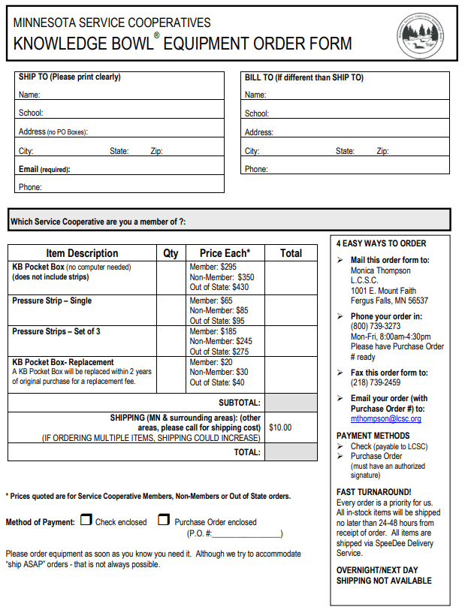

KNOWLEDGE BOWL® Competition Rules
JUDGE

The judge is in charge of coordinating the round as follows:
- While teams are filling out their written round, judges review oral questions. If any reader or judge disputes a question and/or answer, correct it or eliminate it and agree on which alternate question to use. All readers must use the same oral questions.
- Identify yourself to the reader and equipment operator.
- Check teams in and identify team spokespersons. Coordinate this with the equipment operator.
- The reader will wait five minutes for a tardy team and/or team member at the start of any oral round. If the team and/or team member is not seated at the competition table during that five-minute period, the team and/or team members will not be allowed into the competition room until the score check following questions 15 or 30. (If the tardiness is caused by a delay in other competition rooms, the reader/judge will wait to begin the competition without penalty to the team.)
- One of your main duties will be to keep order in the room and ask for “quiet” when unnecessary noise erupts from either teams or the audience. The judge has control of consequences for unsportsmanlike behavior by team members or the audience. Suggested guidelines: first time: official verbal warning; second time: team member is asked to leave the competition room and is disqualified from participation in the competition. In all cases, the competition coordinator is notified as well as the team coaches of affected students.
- As the question is read, the judge should read silently, confirming the correct reading of the question. The judge should stop reading a question if the reader reads in such a way that it is substantially altered. A question read incorrectly should be discarded and an alternate used. The question officially starts as soon as the reader begins to pronounce the question number. Any teams eliminated from a question due to an incorrect answer will be excluded from alternate questions used due to procedural problems, on that same question.
- A dispute on a question or an answer can only be raised by competing team members through their team spokesperson, or their designee, and must be done at the time it occurs before the next question is read.
DISPUTES MUST BE SETTLED IN THE COMPETITION ROOM AS THEY OCCUR, IN A TIMELY MANNER. THE JUDGE HAS THE FINAL SAY.
- If there is a disagreement about an answer, the reader and judge should confer as to whether the answer is acceptable. The judge has the final say.
- Make sure rules are followed as to the reading of questions and operation of equipment.
- During sub-regional and regional competitions, the judge will be required to keep written scores. This will be a double-check or in case of unexpected power failure, etc. If there are any discrepancies, this will be used as the official score. Sample score sheets, included in the appendix, may be copied for competition use.
- Conduct score and door checks only after questions 15, 30, and 45 to verify the scores with the equipment operator and take the final scores to the tabulator, registration table, or otherwise as instructed by the competition coordinator.
- If a sub-regional or regional competition ends in a tie, a reserve set of 15 questions will be available for a tie-breaking round.
- The spokesperson on a team is expected to give the answer. The alternate spokesperson must be designated prior to the expiration of time, by saying “I defer to…” (can point to other member or say their name), or use similar language.
- A team may respond with one piece of relevant information in addition to the answer, which is related to that specific question. Samples might include: author and text, number of degrees in larger angle and smaller angle in a math problem. If more than one piece of relevant and related information is given or if the reader or judge doesn’t know if that second piece of information is correct, the answer will be rejected with a statement of “incorrect answer”. Any information contained in the question is not considered extra information. The articles that begin titles (“a”, “an”, “the”) will be excluded from consideration as part of the answer. Information that is printed in the question (read or unread) is not necessary in the answer, but may be included without penalty. Only answers agreed upon during the questions review will be accepted as correct.
- Pronunciations do not have to be exact. A plausible or phonetic pronunciation is usually acceptable, unless it demonstrates a fundamental lack of understanding about the correct answer (e.g., Malcolm the Tenth is not acceptable for Malcolm X). As a general rule, while leeway may be given to vowel sounds, consonants should be in the correct order (e.g., Olduvai is not the same as Olvudai), and syllables should not be added or omitted.
- A player may be prompted to spell a phonetically close response. In such cases, the exact spelling is not always required (e.g., a player says muh-NAY and is prompted. A response of M-A-N-A-Y would be sufficient to remove ambiguity with Monet).
- No food or beverage may be on the competition tables.
- The only acceptable responses to indicate whether a team received a point are “correct” or “incorrect.” Judges must not respond in any way that may be construed as a hint such as “close” or “almost.” or that may insult a team.
KNOWLEDGE BOWL® Competition Rules
READER
Rules that the reader must follow are below:
- While teams are filling out their written round, readers review oral questions. If any reader or judge disputes a question and/or answer, correct it or eliminate it and agree on which alternate question to use. All readers must use the same oral questions.
- In case of any discrepancies during an oral round, alternate questions are included at the end of each oral round’s question set. The reader and the judge may use them as they see fit. If there is disagreement about an answer, the judge has the final say.
- Identify yourself to the judge and the equipment operator.
- The reader will wait five minutes for a tardy team and/or team member at the start of any oral round. If the team and/or team member is not seated at the competition table during that five-minute period, the team and/or team members will not be allowed into the competition room until the score check following questions 15 or 30. (If the tardiness is caused by a delay in other competition rooms, the reader/judge will wait to begin the competition without penalty to the team.)
- Call out each question number you are reading. The question officially starts as soon as the reader begins to pronounce the question number. Read the questions clearly and loudly. WHEN A TEAM REGISTERS IN, STOP READING THE QUESTION AT THAT POINT! (NOTE: A beep will be heard when the team registers in.) The equipment operator will assist the reader by calling out only the first registered team to answer.
- The equipment beeps when the team’s time is up. The reader indicates that the team’s time is up by saying “Answer…” The team should respond within 3 seconds. If the team does not respond immediately, the reader says, “No answer”, and the equipment operator calls out the second team that registered in. Once the question is read in its entirety, and so noted by the reader to the teams, the teams have 3 seconds to buzz in. If the wrong answer is given by a team, the other teams who have not buzzed in have 3 seconds to buzz in or the reader will move on to the next question.
- Questions may be read in their entirety if no other team has registered in. For example, if the first team registered in fails to answer the question, which has NOT been read in its entirety, and no other teams have registered in, the remaining two teams will have the question read in its entirety. The reader will automatically reread the question, starting at the beginning. If one or two teams have buzzed in, and the remaining team(s) asks a question, the officials will not respond with an answer until any team(s) already buzzed in, have given their answer.

*********QUESTIONS MAY BE READ IN THEIR ENTIRETY ONE TIME ONLY********

- It is suggested that the reader state “correct” or “incorrect” after each answer is given. If two answers are given and one is incorrect, the reader says “incorrect”.
- If any question and/or discrepancy arises, confer with the judge as to whether the answer is acceptable. If there is no judge available, your decision is final. A dispute on a question or an answer can only be raised by competing team members through their team spokesperson, or their designee, and must be done at the time it occurs before the next question is read. Disputes must be settled in the competition room as they occur. The judge has the final say.
- As a question is read, the judge should read silently along, confirming the correct reading of the question. The judge should stop the reading of a question if the reader reads it in such a way that it is substantially altered. A question read incorrectly should be discarded and an alternate used. Any teams eliminated from a question due to an incorrect answer will be excluded from alternate questions used due to procedural problems, on that same question.
- If a question has a fill-in-the-blank answer in the middle, the reader will say the word “blank” for that space. If the answer completes the sentence, the reader will stop reading and not use the word “blank”. For example, “The Eiffel Tower is in “blank”, France. OR The Eiffel Tower is in Paris, ….
- Do not give verbal or nonverbal clues for more information in a situation where a team gives an incomplete answer. Verbal or nonverbal clues include the use of the words “be more specific, please”, pregnant pauses, or gestures. Answers will be evaluated in their original forms.
- The spokesperson on a team is expected to give the answer. The alternate spokesperson must be designated prior to the expiration of time by saying “I defer to …” (can point to other member or say their name) or use similar language.
- A team may respond with one piece of relevant information in addition to the answer, which is related to that specific question. Samples might include: author and text, number of degrees in larger angle and smaller angle in a math problem. If more than one piece of relevant and related information is given or if the reader or judge doesn’t know if that second piece of information is correct, the answer will be rejected with a statement of “incorrect answer”. Any information contained in the question is not considered extra information. The articles that begin titles (“a”, “an”, “the”) will be excluded from consideration as part of the answer. Information that is printed in the question (read or unread) is not necessary in the answer but may be included without penalty.
- When the reader comes to a question where teams may need pencils and paper to arrive at an answer, please announce, “pencil and paper needed” before you read the question. Please identify these questions during the review prior to the oral rounds.
- If the reader comes to a word that may have a questionable pronunciation, please spell the word.
- Pronunciations do not have to be exact. A plausible or phonetic pronunciation is usually acceptable, unless it demonstrates a fundamental lack of understanding about the correct answer (e.g., Malcolm the Tenth is not acceptable for Malcolm X). As a general rule, while leeway may be given to vowel sounds, consonants should be in the correct order (e.g., Olduvai is not the same as Olvudai), and syllables should not be added or omitted.
- A player may be prompted to spell a phonetically close response. In such cases, the exact spelling is not always required (e.g., a player says muh-NAY and is prompted. A response of M-A-N-A-Y would be sufficient to remove ambiguity with Monet).
- The judge has control of consequences for unsportsmanlike behavior by team members or the audience. Suggested guidelines: first time: official verbal warning; second time: team member is asked to leave the competition room and is disqualified from participation in the competition. In all cases, the competition coordinator is notified as well as team coaches of affected students.
- Score and door checks will only be done following questions 15, 30, and 45.
KNOWLEDGE BOWL® Competition Rules
Equipment Operator

The equipment operator should be familiar with operating the KNOWLEDGE BOWL® competition equipment. The rules for the equipment operator are as follows:

- Identify yourself to the reader and judge.
- Ask each team to buzz in for a test run. Coordinate this with the judge.
- When a team registers in, the reader stops reading the question at that point. The equipment operator immediately calls out only the team that registered first by saying the team’s name or letter (a, b, or c).
- The equipment beeps when the team’s time is up. The reader indicates that the team’s time is up by saying, “Answer…”. The team should respond within 3 seconds. If the team does not respond immediately, the reader says, “No answer,” and the equipment operator calls out the second team that registered in.
- If the first team does not answer or answers incorrectly, call out the second or third team that has registered. If the second or third team has not registered, the reader will automatically read the question again, if it has not already been read in its entirety. Once the question is read in its entirety and so noted by the reader to the teams, the teams have 3 seconds to buzz in. If the wrong answer is given by a team, the other teams who have not buzzed in have 3 seconds to buzz in or the reader will move on to the next question.
- Teams must not answer until the equipment operator and reader call on them to answer! No team may answer without having registered in on the equipment.
- The team spokespersons should answer all questions unless they designate an alternate spokesperson prior to the expiration of time.
- If there are any discrepancies, team spokespersons may discuss them with the judge and reader.
- After questions 15 and 30, the equipment operator will announce the team scores, referring to the teams by school name rather than team A, B, and C. Score checks will only be done at these times. Equipment operators will also conduct a strip check.
- At the end of the round, verify the final scores with the judge and announce the final scores to the teams.

ADDENDUM



Knowledge Bowl Guest Expectations

GUIDELINES FOR OBSERVING ORAL ROUNDS;

* Silence all electronic devices.

* Once an oral round has begun and the door is closed, it is too late for visitors to enter the room to observe.

* It’s difficult for players to concentrate when spectators are coming and going. Please do not enter the room until the door is opened for you. Doors will be opened after questions 15 and 30.

* Do not make any comments or non-verbal actions that could be construed as assisting the team/competitor with answers.

* Disputes on a question or an answer can only be raised by the team spokesperson and must be done at the time it occurs before the next question is read. Coaches and spectators are expected to remain silent. The judge makes the final decision on any and all disputes.

Failure to comply with these rules could disqualify
the contestant or the entire team.

Thank you for supporting the Knowledge Bowl program!

